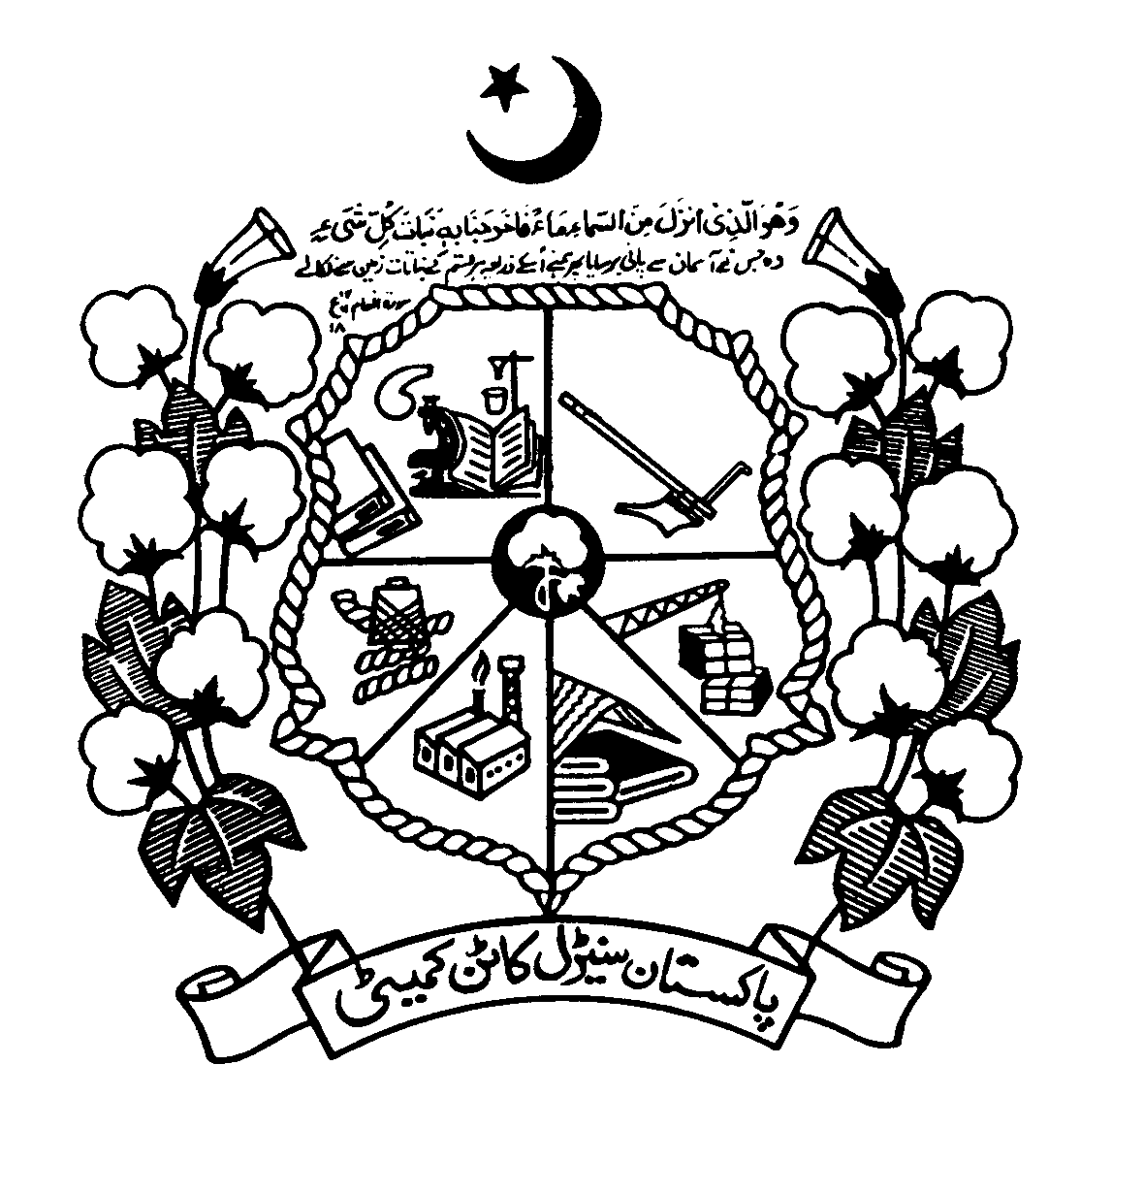
DIRECTORATE OF MARKETING & ECONOMIC RESEARCH
PAKISTAN CENTRAL COTTON COMMITTEE

MINISTRY OF TEXTILE INDUSTRY

GOVERNMENT OF PAKISTAN

Phone No. 061-9201657 Fax No. 061-9201658
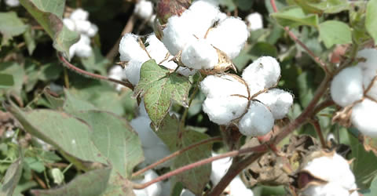

WEEKLY UPDATE ON COTTON CROP
3rd April, 2017

DOMESTIC COTTON CROP SCENARIO
Sowing of cotton crop 2017-18 season is in progress in sindh and about 20,854 acres has been sown. Shortage of irrigation water has become a major hurdle in crop sowing especially in lower sindh. In Punjab,ban on cotton sowing has been lifted due to rising temperatures and less availability of irrigation water.The window of cotton crop sowing has been expanded by lifting of ban on cotton.
Federal committee on cotton (FCC) met on 25th March, 2017 to fix the targets of area and production for the cotton crop season 2017-18. Target of area was fixed at 3.11 million hectares and target for cotton production was fixed at 14.04 million bales of 170kg each.
TARGETS FOR AREA AND PRODUCTION OF COTTON CROP 2017-18
S. No | Province | Area(million hectares) | Production (million bales)
1 | Punjab | 2.42 | 10.00
2 | Sindh | 0.65 | 4.00
3 | Khyber Pakhtunkhwa | 0.001 | 0.002
4 | Baluchistan | 0.038 | 0.038
Total of Pakistan |  | 3.11 | 14.04
Source: Federal Committee on Cotton (FCC) meeting held on 25.3.2017.
SOWING POSITION OF COTTON CROP 2016-17 (Million Hectares)
Province | Target 2016-17 | Area Sown |  | % age Over
 |  | 2016-17 | 2015-16 | Target | Last Year
Punjab | 2.310 | 1.776 | 2.243 | 76.88 | -20.82
Sindh | 0.660 | 0.636 | 0.621 | 96.36 | +2.41
Pakistan | 2.97 | 2.412 | 2.864 | 81.21 | -15.78

Source: Provincial Crop Reporting Departments.

ASSESSMENT OF COTTON CROP 2016-17 (Bales = 170 Kg)
Province | Expected Production (Million Bales)
 | First Cotton Crop Assessment  (06-9-2016) | Second Cotton Crop Assessment  (06-10-2016) | Third Cotton Crop Assessment  (05-12-2016)
Punjab | 7.500 | 7.300 | 6.903
Sindh | 3.733 | 3.700 | 3.600
KPK | 0.001 | 0.001 | 0.001
Balochistan | 0.038 | 0.038 | 0.038
Pakistan | 11.272 | 11.039 | 10.542
Source: Cotton Crop Assessment Committee Meeting (held on 06-9-2016, 06-10-2016 & 05-12-2016)

(Dr. Muhammad Ali Talpur)
Director, DM & ER, PCCC, Multan

