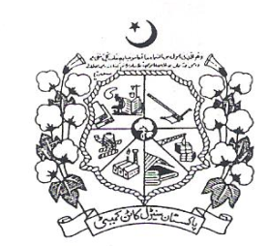

August, 2016
Volume # 45

(Annual Cotton Statistical Bulletin)

DIRECTORATE OF MARKETING & ECONOMIC RESEARCH
PAKISTAN CENTRAL COTTON COMMITTEE
Ministry of Textile Industry
Government of Pakistan
Old Shuja Abad Road, Multan
Phone: +92-61-9201657 +92-61-9201658
E-mail: dmer@pccc.gov.pk Web: www.pccc.gov.pk

