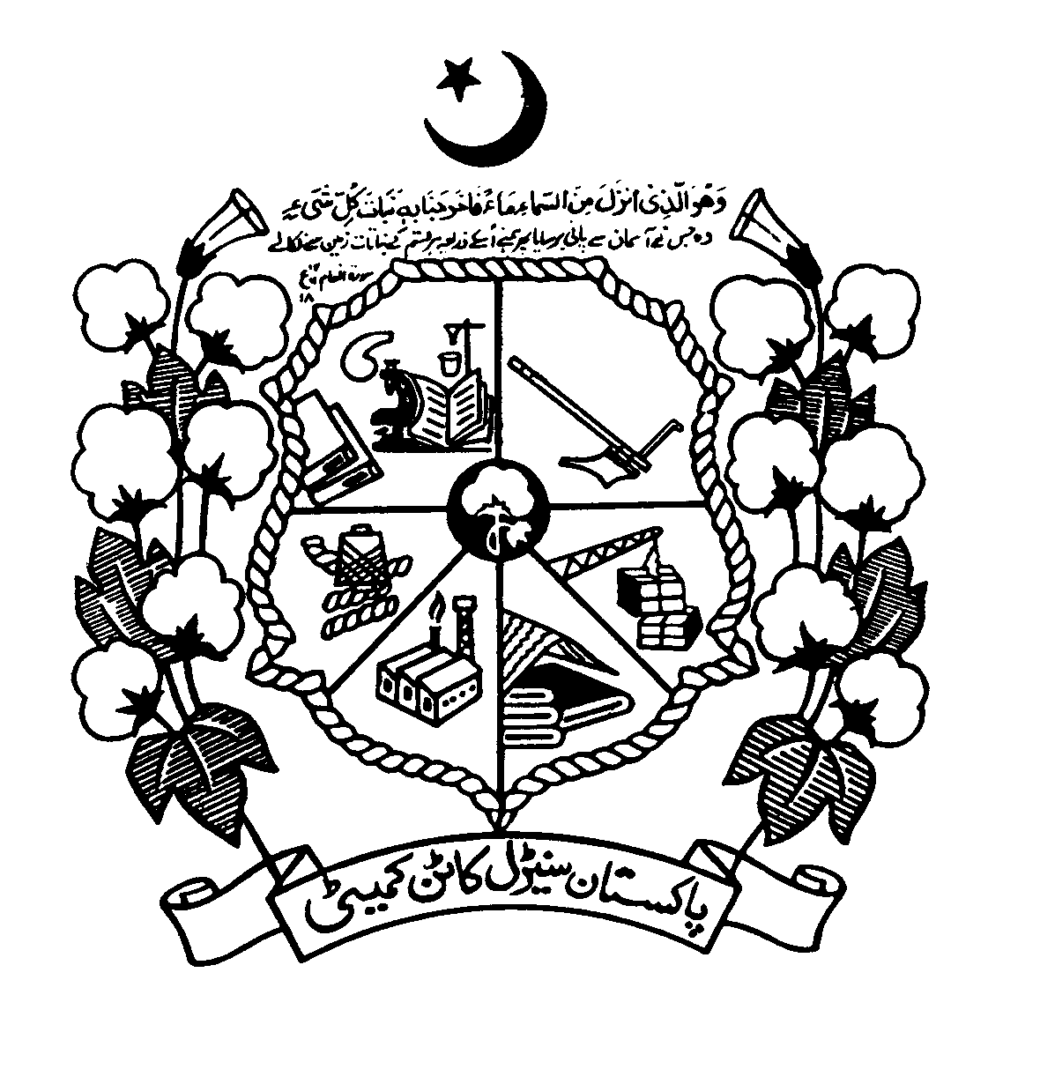
Directorate of Marketing & Economic Research
Pakistan Central Cotton Committee HQ, Multan
Phone No. 061-9201657, Fax No. 061-9201658

DAILY COTTON MARKET REPORT

22ndMARCH, 2017

Market | Current Prices | Prices on same  date last year
1.Cot look Index (Cents/lb)  (21.3.2017) ‘A’ Index | 86.85 | 66.40
II. New York Cotton Market Contract No. 2 (cents/lb)  (21.3.2017)  ‘May’ 2017 Contract  ‘July’ 2017 Contract | 76.84  78.09 | 57.16  57.06
III. China Cotton Index (21.3.2017)  Yuan/M. Ton  (Cents/lb.) | 15943  110.18 | 11902  82.26
1V. Indian Cotton Index (21.3.2017)  Shankar-6  Rs. Per Candy  (Equivalent Cents/lb.) | 43,900  85.75 | -
VI. Karachi Cotton Association  Ex-gin Price (21.3.2017)  Rs. per 40 kgs.  Rs. per maund  (Equivalent Cents/lb.) | 7,288  6,800  78.93 | 5,626  5,250  61.05

NEW YORK COTTON MARKET CLOSING DELIVERY CONTRACT NO. 2. AS ON 21.3.2017
Contract | Open | High | Low | Previous | Close | Change
May-17 | 77.33 | 77.48 | 76.68 | 77.33 | 76.84 | -0.49
July-17 | 78.62 | 78.70 | 77.99 | 78.54 | 78.09 | -0.45
Oct-17 | 75.80 | 75.82 | 75.80 | 76.18 | 75.48 | -0.70
Dec-17 | 75.52 | 75.62 | 74.82 | 75.67 | 74.88 | -0.79
Mar-18 | 75.17 | 75.17 | 74.55 | 75.51 | 74.65 | -0.86

TARGETS OF COTTON CROP AREA AND PRODUCTION FOR THE YEAR 2016-17
Province | Area | Production
 | (Million Hectares) | (Million Bales)
Punjab | 2.310 | 9.500
Sindh | 0.660 | 4.500
Khyber Pakhtunkhwa | 0.001 | 0.003
Baluchistan | 0.038 | 0.098
Total of Pakistan | 3.009 | 14.101
Source: FCC Meeting (held on 23-2-2016)
SOWING POSITION OF COTTON CROP 2016-17(Million Hectares)
Province | Target 2016-17 | Area Sown |  | % Change Over
 |  | 2016-17 | 2015-16 | Target | Last Year
Punjab | 2.310 | 1.776 | 2.243 | 76.88 | -20.82
Sindh | 0.660 | 0.636 | 0.621 | 96.36 | +2.41
Pakistan | 2.97 | 2.412 | 2.864 | 81.21 | -15.78

Source: Provincial Crop Reporting Departments

ASSESSMENT OF COTTON CROP 2016-17 (Bales = 170 Kg)
Province | Expected Production (million bales)
 | First Cotton Crop Assessment  (06-9-2016) | Second Cotton Crop Assessment  (06-10-2016) | Third Cotton Crop Assessment  (05-12-2016)
Punjab | 7.500 | 7.300 | 6.903
Sindh | 3.733 | 3.700 | 3.600
KPK | 0.001 | 0.001 | 0.001
Balochistan | 0.038 | 0.038 | 0.038
Pakistan | 11.272 | 11.039 | 10.542

Source: Cotton Crop Assessment Committee Meetings held on 06-9-2016,06-10-2016& 05-12-2016

SEED COTTON ARRIVALS 2016-17 AND 2015-16 AS ON: 15th MARCH, 2017
Heads | 2016-17 |  |  | 2015-16
 | Punjab | Sindh | Total | Punjab | Sindh | Total
Arrivals | 6,935,134 | 3,787,111 | 10,722,245 | 5,982,481 | 3,766,037 | 9,748,518
Sales to Exporters | 56,100 | 146,256 | 202,356 | 9,975 | 351,266 | 361,241
Sales to Textile Mills | 6,502,983 | 3,545,609 | 10,048,592 | 5,490,746 | 3,254,768 | 8,745514
Sales to T.C.P | - | - | - | - | - | -
Unsold Stock | 373,736 | 94,644 | 468,380 | 472,855 | 157,753 | 630,608
Un-ginned Stock | 2,315 | 602 | 2,917 | 8,905 | 2,250 | 11,155
Source: Pakistan Cotton Ginners Association.

SEED COTTON PRICES CROP 2016-17
Market | Seed Cotton | Raw Cotton (Lint) | Cotton Seed | Cotton Seed Cake Spot
 | (Rs. Per 40 Kgs)
 | 21.3.17 | 21.3.17 | 21.3.17 | 21.3.17
Rahim Yar Khan | 3750 | 7609 | 1875 | 1661
Vehari | - | 7180 | 1768 | 1643
Burewala | - | 7180 | 1768 | 1689
Sindh | Ginneries operation has been closed in Sindh
Source: Market Report.

PROVISIONAL STATEMENT OF EXPORT AND IMPORT OF COTTON (Value= Million Rs)
Exports |  |  |  |  |  | Imports
July-Jan 2017 |  | July-Jan2016 |  | % change |  | July-Jan2017 |  | July-Jan 2016 |  | % change
Qty  Bales | Value | Qty  Bales | Value | Qty  Bales | Value | Qty  Bales | Value | Qty  Bales | Value | Qty  Bales | Value
129,476 | 3,866 | 278,847 | 7,643 | - 53.6 | - 49.4 | 716,188 | 20,844 | 1,328,829 | 43,142 | -46.1 | -51.7
Source: Pakistan Bureau of Statistics.

COTTON BALANCE SHEET DURING 2014-15 AND 2015-16* (Bales= 170 kg)
Sr. No. | Position | 2014-15 |  | 2015-16*
 |  | ‘000’ Bales | ‘000’ M/Tons | ‘000’ Bales | ‘000’ M/Tons
1. | Carryover | 701 | 118 | 398 | 66
2. | Production | 13,996 | 2,379 | 9917 | 1686
3. | Imports | 987 | 168 | 2453 | 417
Total |  | 15,684 | 2665 | 12768 | 2169
4. | Mill Consumption | 14727 | 2504 | 11533** | 1961**
5. | Exports | 559 | 95 | 287 | 49
6. | End Season Stocks | 398 | 66 | 948 | 159
Total |  | 15,684 | 2665 | 12768 | 2169
Source: i) Textile Commissioners Organization
ii) Pakistan Bureau of Statistics.
iii) Provincial Agriculture Department.
*Provisional **Mill Consumption Aug, 2015-March, 2016.
Note: Exports and Imports July-June, 2016 (2015-16 Crop.

(Dr. Muhammad Ali Talpur)
Director
DM & ER, PCCC, Multan

Note: Pakistan Central Cotton Committee (PCCC) has started Tele Cotton Information System
Through SMS Service. All the concerned who intend to receive various information
Through SMS may send their Name & Address to this Cell No: 0334-1121213.

